Manage Message Queues Using Amazon SQS

What is Amazon SQS? (Very simple)
Think of SQS like a buffer or mailbox between applications:
Application A → SQS Queue → Application B
- Sender and receiver don’t need to be online at the same time
- Messages are stored safely
- Very reliable
Create an SQS Queue
- Go to AWS Console
- Search for SQS
- Click Create queue

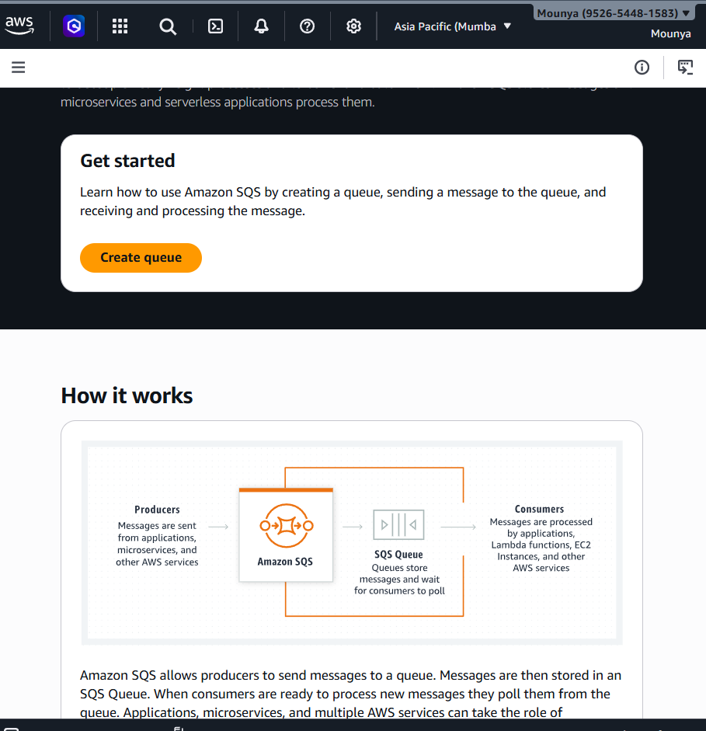

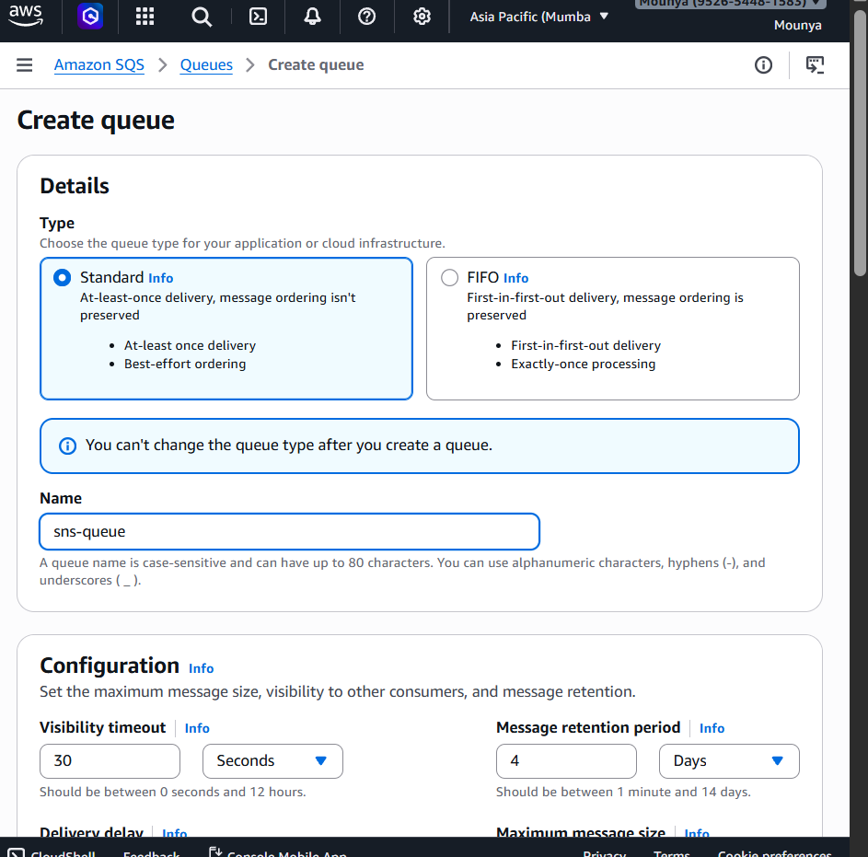

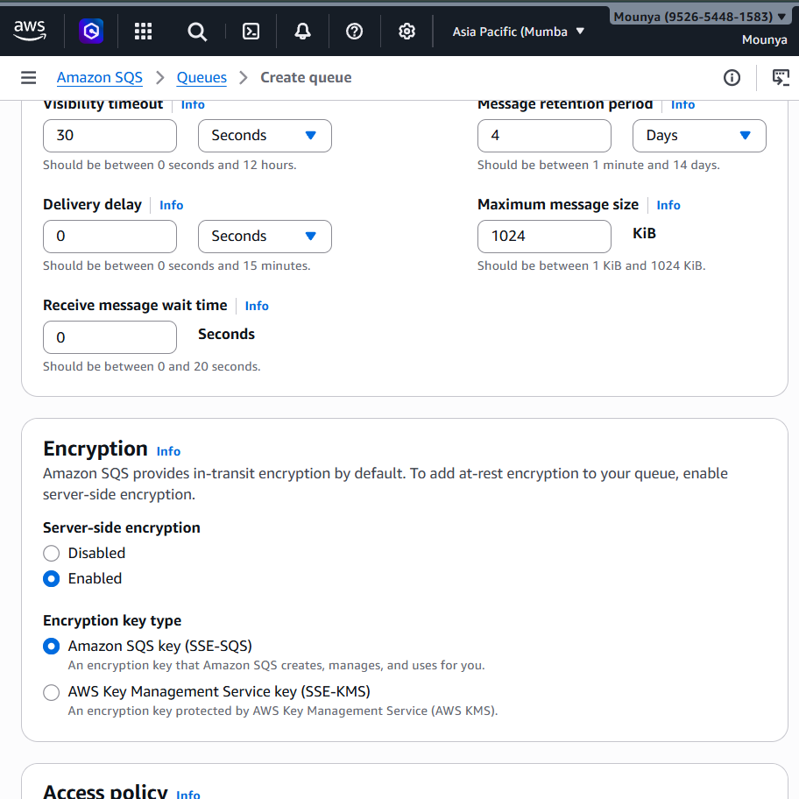

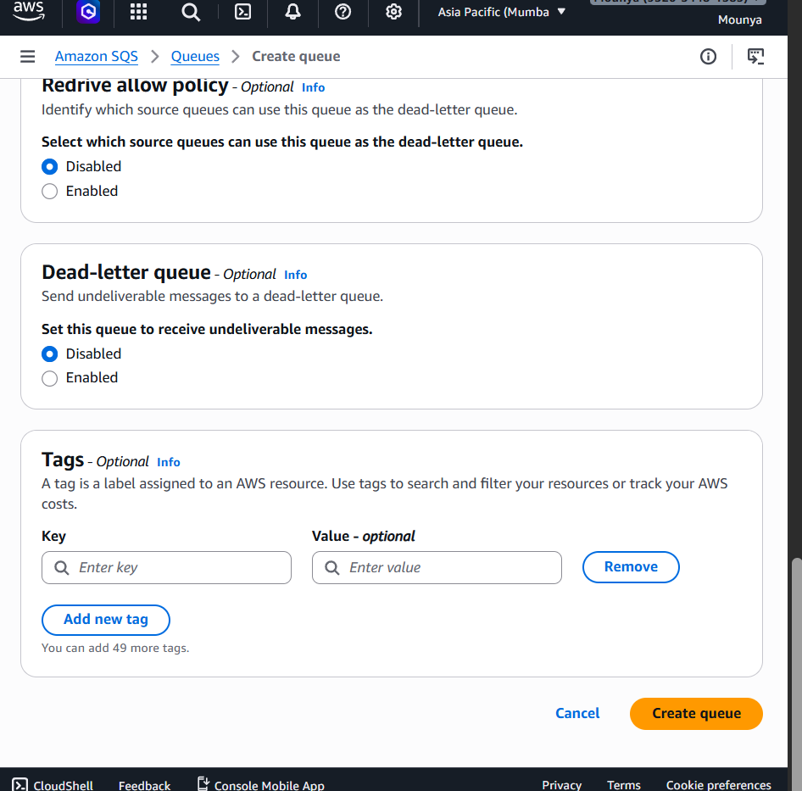

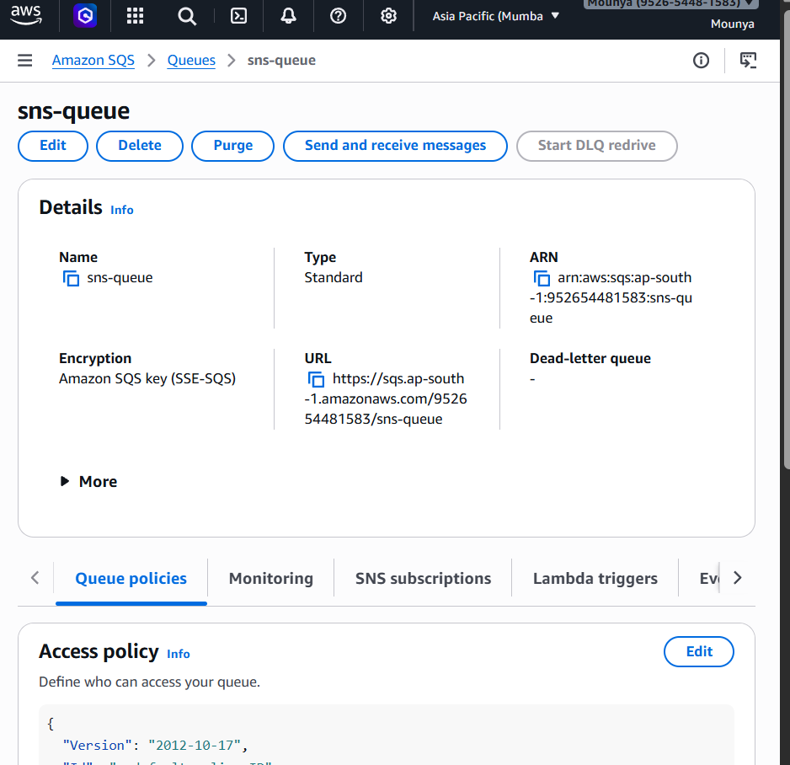
Send a Message (Console)
- Open your queue
- Click Send and receive messages

✅ Send section
- Message body:
- Hello, this is my first SQS message
- Leave attributes empty (optional)
👉 Click Send message
✅ Message is now inside the queue

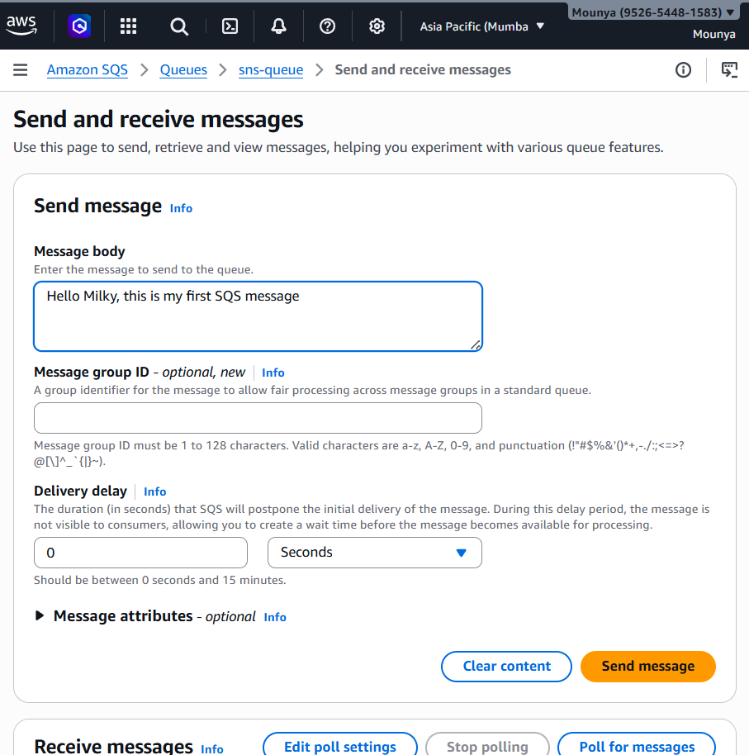

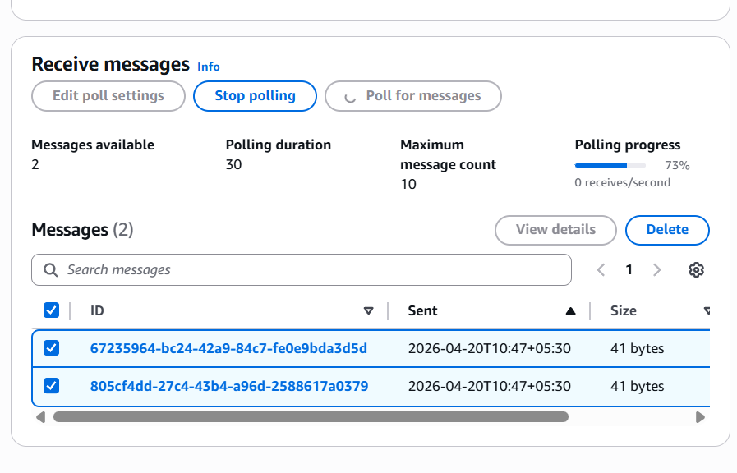
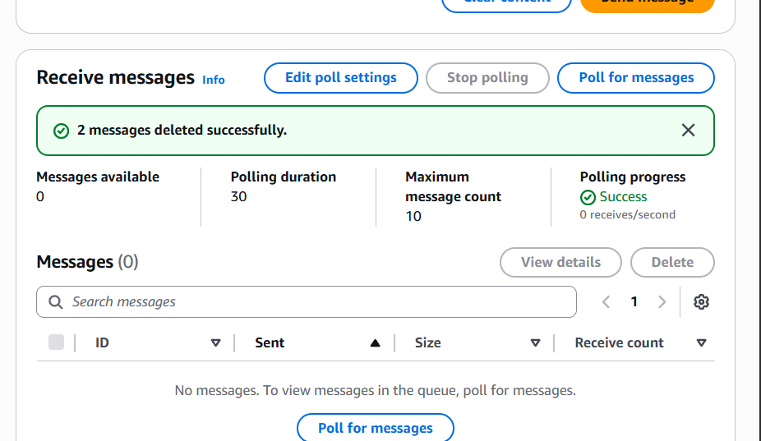
- Message becomes invisible after polling
- Visibility timeout prevents other consumers from seeing it temporarily

✅ Step 4: Delete the Message (IMPORTANT)
After polling:
- Select the message
- Click Delete
✅ Message is permanently removed from queue
⚠️ If you don’t delete it:
- Message becomes visible again later
- Delivered again
Now , go to the AWS CLI:
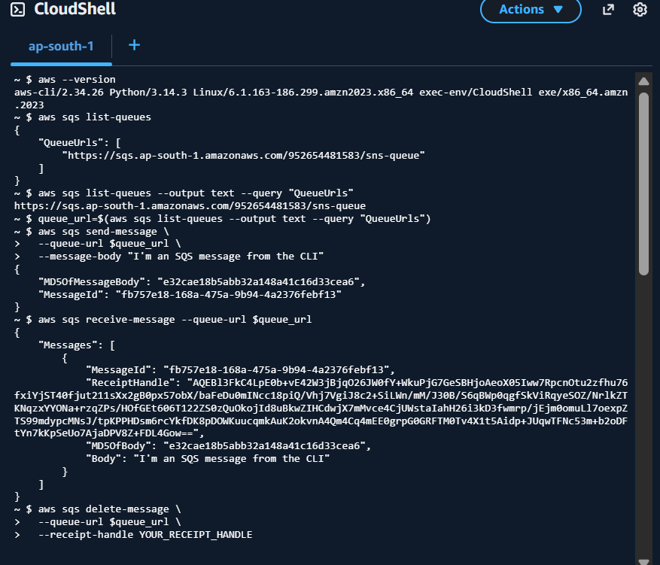
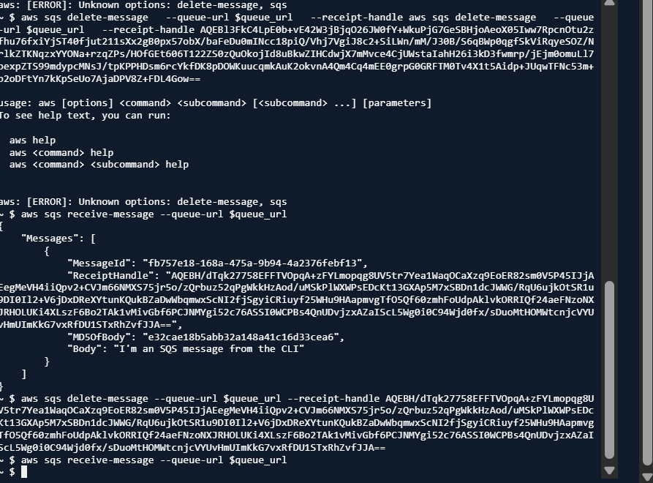

1️⃣ “List queues”
👉 “Show me all my SQS queues”

2️⃣ “Send message”
👉 “Put this message into the queue”

3️⃣ “Receive message”
👉 “Give me one unread message”
AWS also gives a ReceiptHandle here.

❓ What is ReceiptHandle? (THIS confused you the most)
Think of it like this:
ReceiptHandle = temporary ticket proving
“Yes, I read this exact message”
AWS uses it to make sure:
- Only the correct consumer can delete the message
- No one else accidentally deletes it

4️⃣ “Delete message”
👉 “I’m done with this message, remove it”
AWS checks:
- Is the receipt handle valid?
- Was this message actually read?
If yes → delete ✅
FLOW: Send → Receive → Delete

